2014-PL-01-EN Watering the tree
0 ---- | I: ---- | II: medium | III: easy | IV: ----

Answer Type: Multiple Choice Mandatory for: Group II

Body

Linda wants to water her dry apple tree in the garden. She has to prepare a tube which connect the tap with the tree.
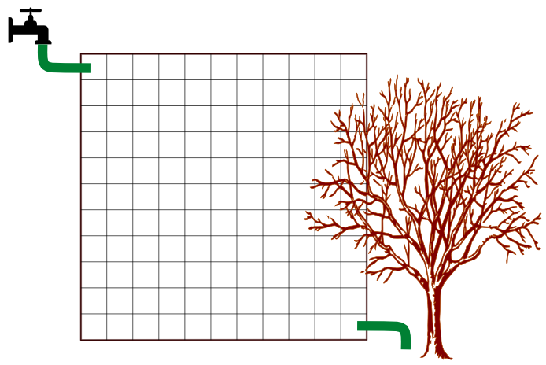
Only tubes of specific shape are available. They can be joined with junctions of two types (see picture below).

There is an example how to create the tube from several pieces:
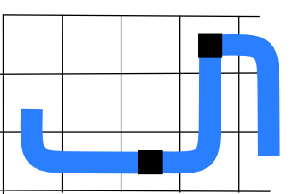

Question

How many pieces of tube is necessary at least to add to join the tap with the tree?

Answer

A) 6
B) 7
C) 8
D) 9

Explanation

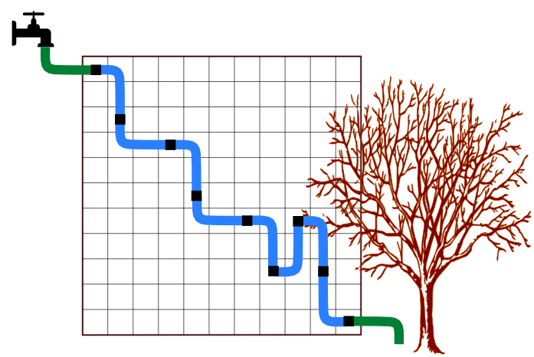
8 pieces of tube is enough to reach the tree like on the picture (this is only one possible example of the solution):
How can we know that we cannot do it with less? Now, that's kind of interesting.

Imagine walking from the square on the top left to the bottom right, at each step going to the cell on the left, right, top or bottom. The top left square is at least 20 steps away from the bottom right - it does not depend on the path you take, for as long as you always go to the right or down (count it!).

Each piece of pipe covers a distance of three steps. For 20 steps you thus need at least seven pipes. Seven pipes will not do, however, since they will bring you 21 steps away from the initial position and you will be of the mark. To prove this, let us say that you made 10 steps to the right, and the remaining 11 steps were in the vertical direction. So, if 10 of them went down, where did the eleventh go? If it went down, you are two farther downward, if it went up, you are one cell to high.

With eight pipes, we make 24 steps, but the additional three steps let us arrange the pipes so that we end up where we want to.

It's informatics

What you had to do in the task is called combinatorial optimization: the problem of finding the optimal solution with a limited set of object – like pipes, in this case.

The proof that we need at least eight pipes is related to another interesting subject: that of the distance between two points. We usually measure straight distances. Now, imagine a city with perfect perpendicular streets. The minimal distance you need to cover to get from one point to another is not equal to the length of a straight line (unless you happen to be a bird), but the number of horizontal plus the number of vertical blocks you need to pass, in whatever order. Such distance is called “Manhattan distance”, by the (mostly perpendicular) streets and avenues of Manhattan in New York.

Keywords

Water

Websites

https://en.wikipedia.org/wiki/Combinatorial_optimization
https://en.wikipedia.org/wiki/Taxicab_geometry

Internal Use

Wording

If you want to add a picture to the explanation of the Manhattan distance, consider 2014-SI-05.

Comments

Author, e-mail, Date (YYYY-MM-DD), Comment.

The story completely changed with the aim to avoid chess pre-knowledge, new grahics has been created. The answer type changed to multiple-choice (it is possible to return to open text too).
Subpictures of tree and tap were taken from Opencliprt.com with the CC-BY licence:
tree: http://openclipart.org/detail/180090/tree-by-arnelsx-180090, author arnelsx
tap: http://openclipart.org/detail/169893/water-by-scyg author scyg
Jiří Vaníček, 2014-06-05

WG7, J. Demsar 2014-06-05: added the text of explanation and the It's informatics part.

Graphics

All images by Jiří Vaníček and from the public sources indicated above.

Files

All additional files for this task (graphics, scripts, etc.)
2014-PL-01-EN Watering the tree.odt (this file)
2014-PL-01-settings.svg
2014-PL-01-explanation.svg

Authorship

Bartosz Bieganowski/bartoszb@mat.umk.pl/Poland

License

Copyright © 2014 Bebras – International Contest on Informatics and Computer Fluency. This work is licensed under a Creative Commons Attribution-NonCommercial-ShareAlike 3.0 Unported License (CC BY-NC-SA 3.0). Visit: http://creativecommons.org/licenses/by-sa-sa/3.0/

